Kevin Ruby
March 10, 2020
Justin Atwell
Literature Review

Abstract

The increased use of technology is something many people love. Engineers are making robots that are capable of accomplishing everyday tasks. This includes packaging products, taxis, producing goods, making business decisions, and much more. Robots can do what humans can do faster, for longer, and without the need for pay. If you are an employer, are there reasons to keep humans on board for jobs robots can do? Many are worried about future needs of employing humans, or the lack thereof. An increase in robots could skyrocket the unemployment rate and could have a dramatic effect on the US markets. This literature review will look what types of jobs robots will take over and examine the changes in the unemployment status of millions as a direct result of automation.

Introduction

Is there really cause for concern? Should the public be worried that they could lose their jobs to automation? We will attempt to discuss the vulnerability of common middle-class jobs to automation. We first must understand some of the types of jobs being automated, and why. The benefits of non-human workers are abundant for some companies, but for others, there is no benefits of automation as robots would only have negative effects on the business.

Robots in Human Roles

The number of robots stepping in and stealing middle class jobs from humans is increasing by the day. Large companies such as Amazon, Tesla, Uber and Goldman Sachs are implementing new technologies to do the jobs of millions around the globe. Automation can perform jobs quicker and more efficient, most of the time.

Beginning Steps towards a future of automation
It has always been a dream of companies to have technology that is able to do the work of humans. General Motors was the first known company to replace human work with that of a robot. In comes Unimate, a robot designed to work in a factory in the early 60’s. It was pre-programmed, meaning that every day it performed the same task by doing the same things. It's job consisted of moving hot metal pieces. This was a dangerous task, so creating a dispensable ‘worker’ seemed like a good choice. [2]

Amazon Automation
Amazon has been replacing the simple yet popular job of packing orders. By the end of 2019, the tech giant had over 200,000 robots as part of its working fleet [3]. This makes up a whopping 25 percent of Amazon's workforce, up from 20 percent in 2017 [1]. Most of these robotic workers are those crawling the warehouse floors stocking shelves and moving products around. Amazon has been testing these robots to have abilities to receive an order, locate the product in the warehouse, retrieve this product, and package it up in a box with a label making it ready for shipment.

Package handling is not the only job Amazon is replacing. They have been researching and developing new and faster ways to deliver your package right to your door. Suppose you are in desperate need of a stapler at the office. You log onto Amazon, pick your ideal stapler, and check out. Behind the scenes, the warehouse receives the order, packs it up in a box, and ships it directly to your office. Seems normal, right? It's something that all Amazon users experience. Now imagine this scenario, but the only pair of human hands the stapler touches along its journey is yours, at its final destination. We already know the warehouse is using technology to package items, but what about the hands of the mailman? Prime Air, as they call it, is a project that uses small drones to deliver your package in 30 minutes or less. Drones that are on the verge of replacing delivery truck drivers and mailmen. Robotic advances are responsible for a net loss of 24,000 jobs at Amazon, with more projected on the way as the company continues to build and integrate machines into their everyday tasks. [1]

Automation across Companies
Uber, a rideshare company, has about 22,000 drivers worldwide. Most of their drivers are part time workers to pick up a few extra bucks, but there are some full-time employees. Since 2015, Uber has been in the works developing self-driving cars. Cars that drive themselves, as in no need for human drivers. Once fully implemented, Uber will have no need for 22,000 drivers.
The company will eventually be 100 percent internal, meaning there are no outside employees such as drivers. This creates some full-time jobs that are responsible for the creation and maintenance of the vehicles, however the part time drivers will be forced to look elsewhere for extra income.

The farming industry is also prone to automation, and many farmers have begun to implement robotic harvesting tools. Some crop farms are fully automated - they are planted, watered, maintained and picked by machines. Gone are the low-level jobs that are responsible for the crops.
Dole Plantation, located in Hawaii, believes the opposite – human workers are necessary for a good product. “It takes knowledge, time, and plenty of patience to grow and harvest pineapple crop, most of this process cannot be automated, and must be done by hand.”, Dole writes on their website.

Tesla, a self-driving car company is an example of where automation failed. Elon Musk, CEO, had the goal to produce 5000 cars per week at just one factory. 5000 cars per week was deemed humanly impossible, so Musk attempted to boost productivity by automation. His vision was a completely automated assembly line, or hyper-automation. Fully implemented, the company couldn’t produce 5000 cars a week, they couldn’t even get close to that goal. “Production Hell” was the name Musk gave to his fleet of robots. After much consideration, the robots were replaced by humans, the reverse of what is expected. The assembly line robots just couldn’t deal with unexpected orientations of objects like nuts and bolts, or complicated maneuvering between the car frame. Every such issue would cause the assembly line to stop. In the end, it was far easier to substitute humans for robots in many assembly situations [4].

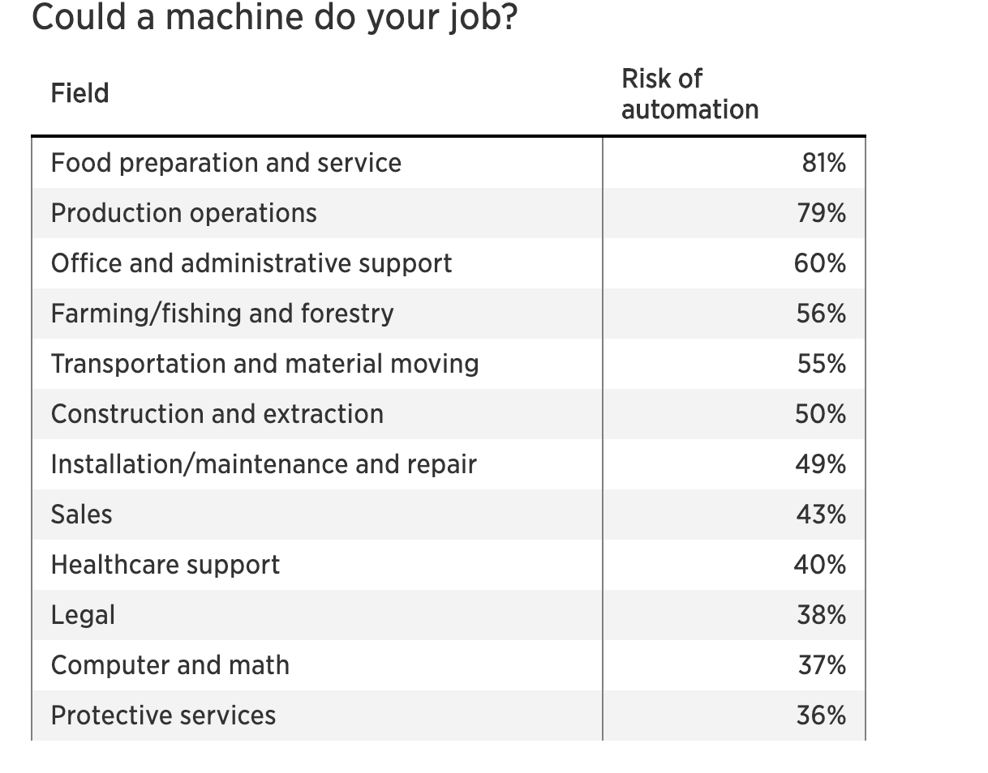
Figure 1. Sectors of the workforce that show high vulnerability to automation

Why Automate?

Looking from Amazon’s point of view, why would you not integrate automation? Robots are up to 400 times more productive. A human warehouse ‘picker’, who is responsible for gathering products off shelves to be packed, can pick an average of 100 items per hour. Automation allows 300-400 items to be picked per hour [4]. Converting these numbers to a per week basis, humans will pick 4000 items per week, whereas their automated counterpart can pick up to 67,200.The large difference in this theoretical number is due to the fact robots do not need rest or weekends off, thus will work every hour in the week. They do not get sick, need time off, or quit on the spot.

Firms have discovered that robotics, machine learning, and artificial intelligence can replace humans and improve accuracy, productivity, and efficiency of operations [5].

Productivity is at record levels, innovation has never been faster, and yet at the same time, we have a falling median income and fewer jobs. People are falling behind because technology is advancing so fast and our skills and organizations aren’t keeping up [7].

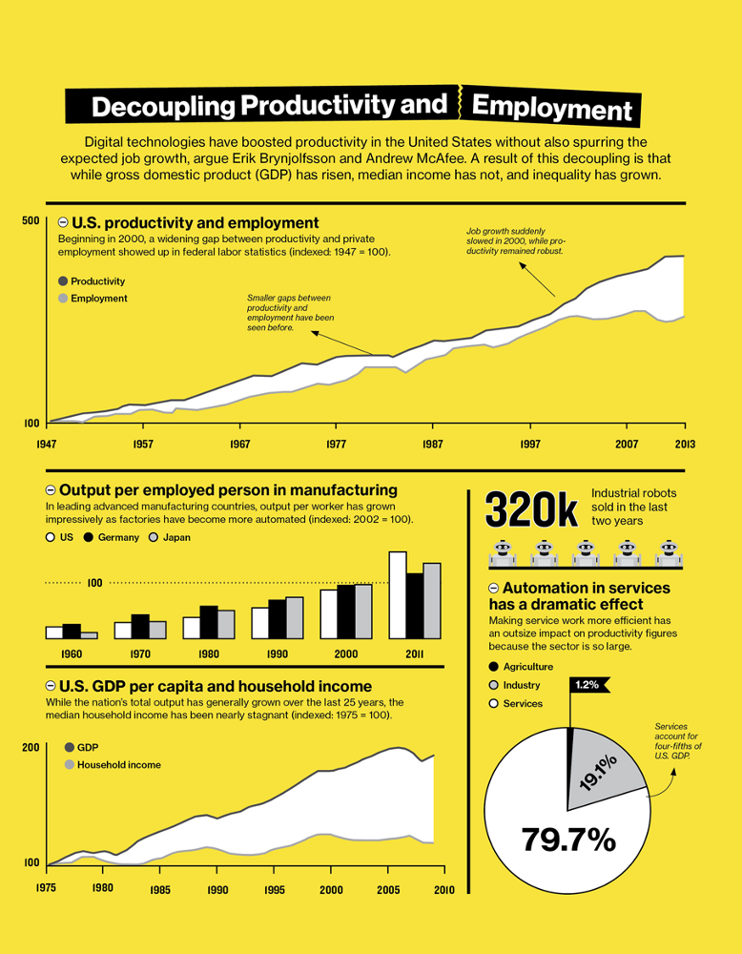
Figure 2. According to the figure above productivity is at an all time high, while employment has stayed fairly constant in the last 20 or so years.

Are we really losing jobs?

Replacing hard working humans with robots can have a large effect on the economy. Middle-class job loss seems inevitable with the increase in automation based on trends from the past.

Since the Industrial Revolution in the 1700s, improvements in technology have changed the nature of work and destroyed some types of jobs in the process. In 1900, 41 percent of Americans worked in agriculture; by 2000, it was only 2 percent. Likewise, the proportion of Americans employed in manufacturing has dropped from 30 percent in the post–World War II years to around 10 percent today [7].

The sharp decrease in percentages is likely due to automation, as companies have found cheaper and more efficient robotic alternatives to humans.

Substituting robots in for humans is creating a “displacement effect”, as technology can perform a human job more cost-effectively for a given standard of quality. This displacement effect is predicted to be very impactful. The number of manufacturing jobs that could be displaced by industrial robots by 2030 is projected to be 20 million. This accounts for 8.5% of the global manufacturing workforce. This estimate is based on data that has been recorded for the last two decades. In all, around 1.7 million manufacturing jobs have been wiped out since 2000 due to the global rise of industrial robots. Since 2004, each new industrial robot installed in the manufacturing sector displaced an average of 1.6 workers from their jobs [6].

The increase in industrial robots is astonishing. 2030 is not far away, and if these predictions are correct, the middle-class will have issues finding and keeping jobs.

“If current trends continue, it could well be that a generation from now a quarter of middle-aged men will be out of work at any given moment.” - Former U.S. Treasury Secretary Lawrence Summers, on the effects of automation and how it could impact the workforce.

The data cannot be excused, it is easy to see we are losing jobs to automation. The loss of jobs are countered by large companies such as Amazon.

Amazon counters job loss accusations by stating they are implementing automation to assist the workers with jobs. Amazon warehouse employees are said to walk 12 miles a day searching for products to package them up [3]. The robots will be doing the strenuous jobs and heavy lifting, while the workers can focus on packing the product that was just delivered to them and making sure it's ready to be sent to the customers. The creation of automation will also create many jobs, as the company states that robots still need to be made, tested, and perfected.

Companies acknowledge many jobs will be lost through technology improvements but argue that new ones will be created. There may be fewer people sorting items in a warehouse because machines can do that better than humans. But jobs analyzing big data, mining information, and managing data sharing networks will be created. According to those firms, the job gains and losses will even out over the long run [5].

The issue lies here. Nobody is arguing that automation won’t bring new jobs. The point is automation is stealing middle class jobs.

According to the U.S. Department of Education, there will be a 14 percent increase in STEM jobs between 2010 and 2020. Issue is, only 16 percent of American high school seniors are proficient in mathematics and interested in a STEM career [5].

Its these STEM students that are gaining jobs from automation. STEM students only account for a small percentage of the population. Out of this small population, an even smaller percentage goes on to the higher education that large tech companies are requiring for new employees. Where do non-STEM students work when their jobs are replaced by automation? This is the question that puzzles economists worldwide, and if we cannot find jobs where humans are more efficient, the economic markets could come crashing down.

Next Steps

Is the process of automation really having an effect on the economy? This question cannot be answered yet as we do not have data to support this claim. Automation is too young to have any observable effects on our economy.

This literature review included examples of jobs prone to automation as well as information on unemployment due to automation. With time, research can be conducted to examine if this unemployment has any direct effects on our economy or the economy worldwide.

Sources
- Erin Winick, “Amazon’s investment in robots is eliminating human jobs” MIT Technology Review, December 2017.
- Robots in the Beginning, Consortium on Cognitive Science Instruction
- Jason Del Rey, “How robots are transforming Amazon warehouse jobs – for better and worse”, Vox, December 2019
- Ryan Kottenstette, “ Elon Musk was not wrong about automation…”, TechCrunch, March 2019
- Darrell M. West, “What happens if robots take the jobs?” Center for Technology Innovation at BROOKINGS, October 2015
- Adrian Cooper, “How Robots Change the World”, Oxford Economics, June 2019.
- David Rotman, “How Technology Is Destroying Jobs” , MIT Technology Review Magazine, July/August 2013.
- David Autor, “Is Automation Labor-Displacing? Productivity Growth, Employment, And The Labor Share”, National bureau of economic research, July 2018

